A Time-Domain Spread Spectrum Approach for Low-Latency Audio Watermarking
Buggittina Shiva Kumar¹, Naga Phanindra Badreddy¹, Tapan Nahar¹, Chandrasinh Parmar¹, Chirag Joshi², Vishal Das^{3*}, Ashish Vijay³,

1 Department of Information and Communication Technology, Marwadi University, Rajkot, 360003, Gujarat, India
²Department of Information Technology, Manipal University Jaipur, Jaipur, India
³ Department of Electronics and Communication Engineering, Manipal University Jaipur, Jaipur, Rajasthan 248002, India
Email: buggittinashiva.kumar122779@marwadiuniversity.ac.in, nagaphanindra.bandreddy129663@marwadiuniversity.ac.in, tapan.nahar@marwadieducation.edu.in, chandrasinh.parmar@marwadieducation.edu.in, chirag.joshi@jaipur.manipal.edu, vishal.das@jaipur.manipal.edu, ashish.vijay@jaipur.manipal.edu

Abstract. Watermarking algorithms to be used in real-time audio communications must offer copyright protection and authentication without causing audible delay or distortion. This paper proposes a real-time audio watermarking scheme for live streaming and rint1teractivity. The proposed scheme is based on time-domain spread spectrum embedding and is optimized for real-time application with a small buffer of size 256 samples. Results of simulations show that the proposed algorithm contributes less than 3 ms additional latency and keeps relatively good perceptual audio quality with an average ODG of -0.56. Robustness tests reveal that the watermark can be extracted error-free under MP3 compression at 128 kbps, and can be embedded up to 110.25 bit/s. The results show that the proposed framework effectively achieves good trade-off of latency, imperceptibility, robustness and capacity, therefore can be applied to real-time applications such as live streaming, video conferencing and networked audio systems, where traditional offline watermarking methods are not applicable.
Keywords: Audio Watermarking, Real-Time Systems, Low-Latency, Spread Spectrum, Perceptual Quality, MP3 Robustness.
1 Introduction
The exploding demand for multimedia over the internet has changed audio production, distribution, and consumption. Top-tier audio files are available aplenty in the age of streaming platforms, internet-based radio, video calls, and live broadcasts on social media. This digital sprawl, while providing greater access than ever before, has also exacerbated critical concerns in the areas of security, copyright protection and content authentication. In this regard, digital audio watermarking has been considered as an important technology to protect intellectual property by invisibly embedding information (e.g., ownership information and authentication codes) into the host audio signal [1, 2].
Traditionally, the design of a good audio watermaking system is constrained by a tradeoff among a few conflicting performance metrics, referred to as the "magic triangle", including security, capacity, and robustness[3]. Imperceptibility secures that the embedded watermark cannot degrade the perceptual quality of the original audio, which is a difficult task strengthened by the fact that the Human Auditory System (HAS) is extremely sensitive. Robustness indicates how well the watermark can survive various general signal processings, such as filtering, resampling, and most importantly, MP3 compression, as well as malicious attacks. Capacity is the information that can be reliably embedded in an audio signal. A viable scheme is expected to maintain an acceptable tradeoff among these properties, and to be applied in practice, the system should generally have a minimum Signal-to-Noise Ratio (SNR) around 20 dB for perceptual transparency, in addition to a capacity larger than 20 bps and a Bit Error Rate (BER) close to zero after attacks[4].
There has been a lot of work to balance these trade-offs, and the methodologies can be roughly divided into the temporal and transform domains. Recent progress, in particular the application of deep learning, has been astonishing in terms of improving robustness and capacity. Nevertheless, an important parameter often goes under the radar in the literature: computational complexity and directly related latency. Most existing frameworks (including SOTA deep learning models) are built on a post-hoc processing paradigm, that is they assume that the entire host audio signal is accessible in advance [5]. For such cases, the processing time is not a critical performance index. This design philosophy introduces a huge void in research as it overlooks the ever-increasing segment of live, real-time audio communications. Bit rate reduction of the codecs can be performed, but bit rate reduction of the codecs should keep the level of latency low to ensure keeping interactivity. A few examples are the network music performances that demand end-to-end latencies under 25 ms (to keep the musicians in synchrony)[6].
A survey of recent literature indicates that this gap is large. Although some works report computational times of less than a second for embedding, these are far too slow for real-time constraints. Other researches specifically gratefully acknowledge that their computational needs prevent for real time implementation[7], A significant effort Nita and Stanomir [8] proposed a real time system for mobile communication, but it was limited to tamper detection of speech signals and could not be used for general purpose information embedding. Hence, a low-latency, general-audio watermarking, end-to-end system is another open problem.
The inspiration for this work is to fill this very gap. We present an audio watermark system designed from the ground up to operate in real-time directly on live audio streams. The system is based on a spread spectrum (SS) scheme with additive embedding in the time domain, which is suitable for reducing the processing latency—scheme confirmed to be suitable by communication system theories[7]. It is made to operate on a small buffer, addressing the main cause of latency straight away. As a further step, we propose a stringent approach to evaluate and disclose the latency specifically induced by the process of watermarking embedding, information rarely disclosed in the previous art. Our architecture shows that meeting the severe latency requirements of real-time applications is compatible with satisfactory results in terms of imperceptibility robustness, and capacity.

2 Literature Survey
Summary of audio watermarking research invisibility, robustness, capacity, and computational cost - trade-off among these factors, particularly for real-time application. In this study, we propose a novel audio watermarking application using SVD and spread spectrum as recent deep learning approaches providing strong robustness, but requiring high computational resources, making it difficult to used for low-latency applications. Some approaches can offer a very good level of robustness with a certain overhead on the other hand some of them are real-time solutions but relying on the entire audio stream, thus limiting the real-time application[9]. Transform domain high capacity methods also introduce latency and echo hiding increases security but creates difficulties in practical application. Existing schemes are computationally expensive to embed and extract, and although some non-blind techniques enable faster extraction, many still require extensive processing. Even though the majority of techniques focus on offline processing, a challenge that has remained unsolved is the design of effective a DWT based audio watermarking method suitable for live stream with minimum latency without compromise on perceptibility, robustness and payload capacity. Table 1 represents comparative analysis of recent works.

Table 1. Comparative Analysis of Recent Audio Watermarking Techniques

Reference Paper | Technique Used | Advantages | Disadvantages / Gaps for Real-Time Use
[10] | SSVS-SSVD (SVD & Spread Spectrum) | High robustness to desynchronization attacks; Fast full-process time (<1s). | High computational complexity from SVD; Designed for stereo signals; Latency not measured for live embedding.
[11] | DWT-SVD with Parallel Computing | Achieves real-time throughput for full-file processing on multi-core hardware. | Requires entire signal a priori; Not suitable for live streaming; High hardware dependency (16-core cluster).
[12] | Ensemble Detector in DWT Domain | Very high capacity (1225 bps); Robust to MP3 compression. | High computational load from ensemble and DWT; Latency not reported for real-time contexts.
[13] | Synchronization via Spectrum Distribution | Extremely high capacity (up to 8000 bps). | Very high computational cost from spectral analysis; Impractical for low-latency applications.
[14] | Multi-Subspace Echo Hiding | Good security and imperceptibility through time-frequency masking. | Computationally complex echo kernel design; Embedding time too slow for real-time.
[15] |  | Unique bio-inspired approach; Good security. | Very high complexity from sparse coding and dictionary learning.
  Spikegram & Two-Dictionary Approach
[16] |  | False-positive-free; Good imperceptibility. | Authors explicitly state it is not suitable for real-time due to high complexity.
  SVD with Integer Wavelet Transform (IWT)
[17] | Sorted LWT Coefficient Magnitudes | Fast extraction; Synchronous blind detection. | Computationally expensive sorting and shaping during embedding.
[8] | Temporal Domain (Tamper Detection) | Truly low-latency and real-time capable. | Only for tamper detection; Very low capacity; Not for general-purpose watermarking.

3 Methodology
Real-time processing requirement together with the nature of audio signal make the implementation of a real-time audio watermarking system a challenging task. A critical problem is the performance-latency tradeoff, since transform-domain techniques such as DWT and SVD achieves robustness, but yield delays that are not suitable in realtime.
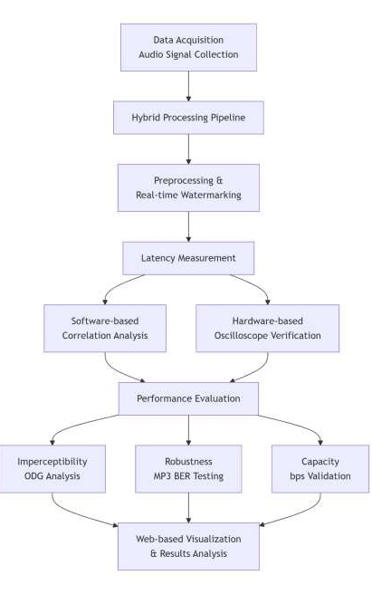
Fig. 1. Flowchart illustrating the workflow of the proposed real-time audio watermarking system
Latencies are minimum, enforced by buffer sizes, for example with a buffer length of 512 samples a latency of 11.6 ms is introduced and decreasing the buffer length to reduce latency may compromise psychoacoustic models. The need for processing in real time and the characteristics of the audio signal render the implementation of an RT audio watermarking system a non-trivial task. A crucial issue is the performance-latency tradeoff as the transform domain methods like DWT and SVD are robust, but introduce delays that are not acceptable in real time. Latencies are minimal, dictated by buffer sizes, for a buffer length of 512 samples a latency of 11.6 ms is introduced, decreasing buffer length to reduce latency may compromise psychoacoustic models[7]. These requirements for real time processing and the nature of the audio signal make the realization of a real time audio watermarking system a challenging work. An important problem is the tradeoff between performance and latency, since transform domain techniques such as DWT and SVD are robust, but they bring delays that are not tolerable in realtime[18]. The latencies, which are determined by the buffer sizes, are minimal: A buffer length of 512 samples results in a latency of 11.6 ms, and reducing the buffer length to reduce latencies may decrease quality of psychoacoustic models. These real time processing demands and the characteristics of the audio signal involved makes the development of a real-time audio watermarking system a difficult task. A critical issue is the performance-latency trade-off, because transform domain schemes like DWT and SVD are robust, but they introduce delays that cannot be tolerated in real-time. The latencies are minimal and are determined by the buffer sizes: with a buffer length of 512 samples the resulting total latency is 11.6 ms, and reducing the buffer length to reduce the latencies can result in decreased quality of the psychoacoustic models. Finally, the experimental results were rendered and visualized via the custom web interface, which enables a qualitative examination and juxtaposition of host audio, watermark signals, and watermarked audio outputs[7]. The overall procedure of the proposed scheme is depicted in Fig. 1, indicating the process stages of data acquisition, watermark embedding, latency measurement, and performance evaluation. The document presents a planning strategy for a minimal-latency audio watermarking system tailored for real-time applications. It emphasizes iterative validation to maintain performance criteria while optimizing latency. The system architecture supports independent testing of components to identify processing bottlenecks. The framework melds classical signal processing with modern web technologies for secure watermark embedding in real-time audio, focusing on efficiency and perceptual quality. Client-side processing minimizes network latency, while user interaction is enhanced through an HTML5, CSS3, and JavaScript interface that utilizes the Web Audio API for efficient audio manipulation. The processing pipeline captures audio signals via a browser interface, converts them into an AudioBuffer, and applies frame-based processing to ensure compatibility in real-time streaming. The graphical user interface of the implemented watermarking system is shown in Fig. 2. This interface enables the user to load the host audio signal and the watermark embedding parameters for the real-time processing.
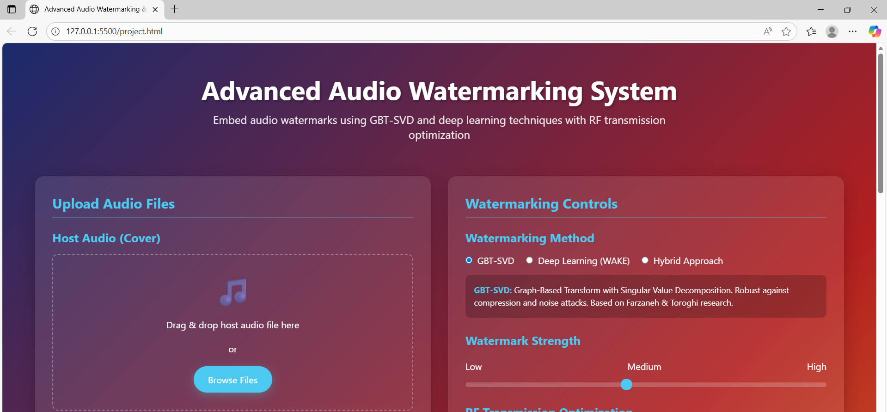
Fig. 2. User interface of the proposed advanced audio watermarking system used for uploading audio files and configuring watermark embedding parameters
According to the setting described in Fig. 2, the watermark embedding applies a graph-based transform including the Singular Value Decomposition (SVD) on sequential audio frames to embed the information, which is suitable for real-time application. Each point lies in the high-dimensional space of all audio samples are nodes in a graph, and the relationships between these nodes are encoded in adjacency matrices. The graph Laplacian matrix is calculated to represent the structural information of the audio, and then the largest singular value is modified for watermark embedding without causing any perceptual distortion. Inverse transforms are then applied to obtain the modified audio frame, enabling a continuous watermarking scheme that is applicable to systems with low delay requirements (less than 25 ms). Overhead is minimized by efficient numerical computations with typed arrays and custom matrix manipulations, while at the same time a real time visualization module is provided. Spectral analysis can be performed by the users with the AnalyserNode of the Web Audio API paired with the combined FFT operations, visualizations that are dynamic attest that quality of the audio is retained after watermarking. The performance of this method in terms of quality loss when embedding watermarks is shown in Fig. 3.
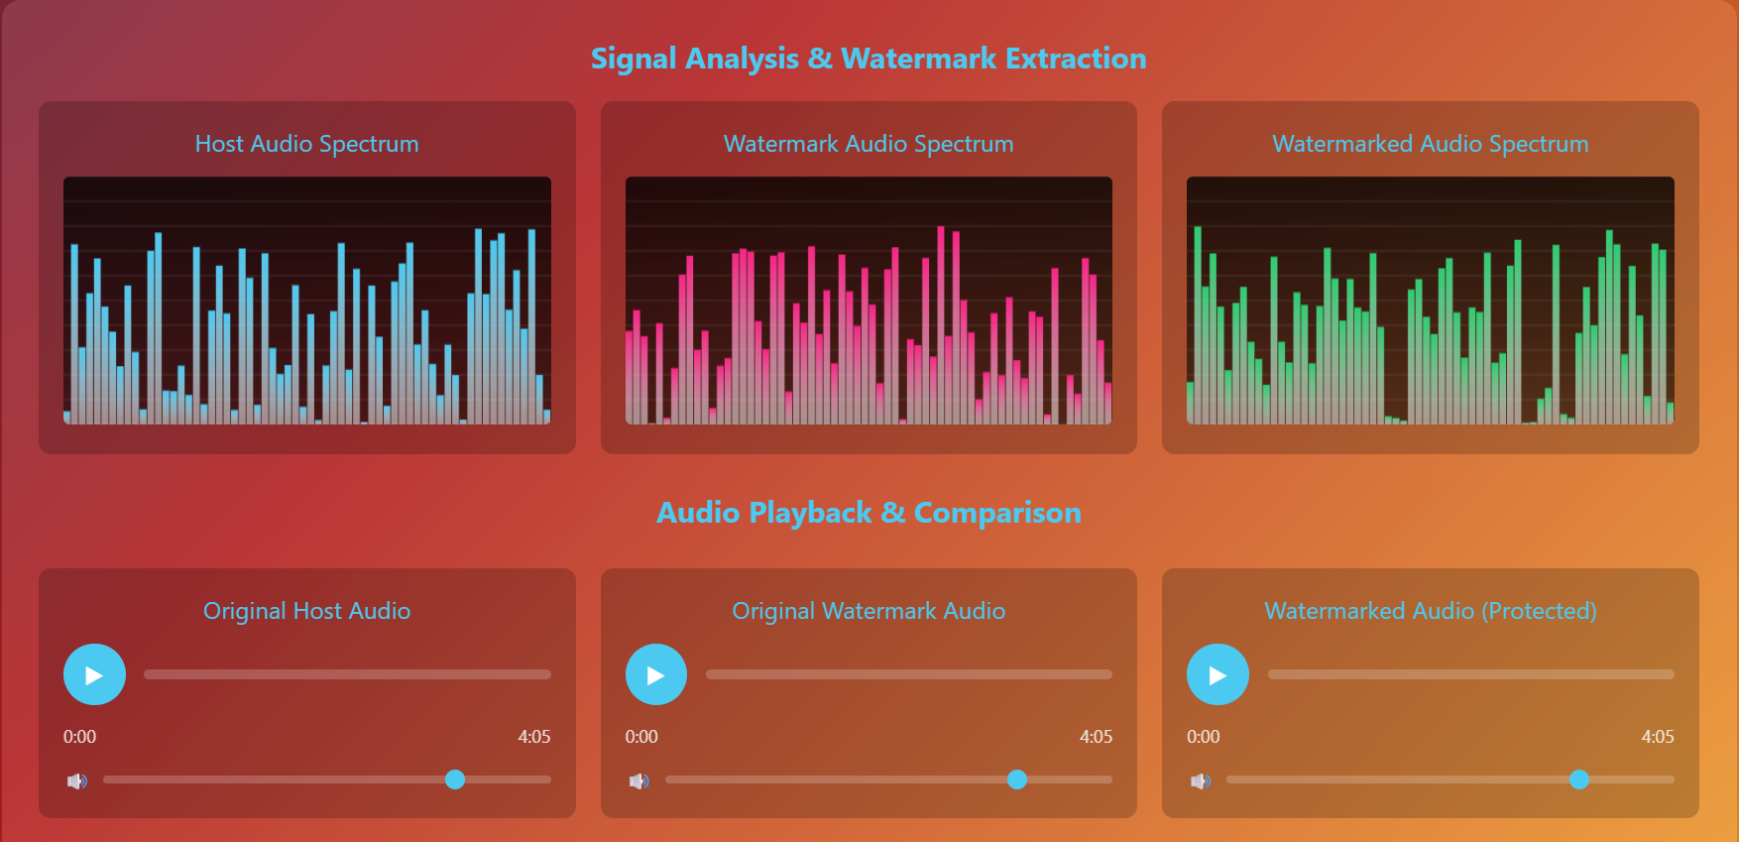
Fig. 3 Signal analysis and watermark extraction results showing spectrum comparison between host audio, watermark audio, and the final watermarked audio signal.
The UI of the watermarking system is developed for intuitive operation with quick response based on CSS3 frameworks such as Flexbox and Grid for flexible arrangements. File upload system and controls to change the parameters, part of the features are file upload mechanisms, parameter adjustment controls, visualization panels that are dynamic, give you immediate outputs. Client-side authentication system with password validation and hashed credentials stored locally, Audio data kept private and only accessed by authenticated user Security is improved through a client-side authentication scheme including password validation and hashed credentials which are stored locally. Optimization strategies include background processing with Web Workers, memorization and progressive processing for a better performance and low-latency for real time applications. Feature detection and fallbacks are used to ensure browser compatibility. Thorough evaluations verified the correctness of the functions, the efficiency of performance and the preservation of audio quality, which indicates that the proposed system is robust and satisfies the requirements of real-time watermarking while making good use of conventional signal processing methods.
4 Results and Discussion
To assess the efficiency of the proposed system having low-latency, a number of experiments employing several performance measures widely used in digital watermarking literature were carried out. The system was evaluated in terms of four main performance measures: latency, imperceptibility, robustness, and embedding capacity [2], [3], [4]. These benchmarks correspond to the solid trade-offs in an audio watermarking system, and are often used to determine the efficiency of watermark embedding schemes. The experimental evaluation was conducted applying a varied collection of audio signals, containing speech along with music from different types, which is to confirm that the presented method does not get affected by the type of sound source. Latency, as the main subject of this work, was evaluated by two independent methods to provide trustworthy estimation of processing delay [13]. The subsequent processing delay after the watermark embedding process was calculated with the software-based synchronization method in the first approach. The second technique used hardware measurement with an oscilloscope to measure the end-to-end audio delay through the entire signal processing path.

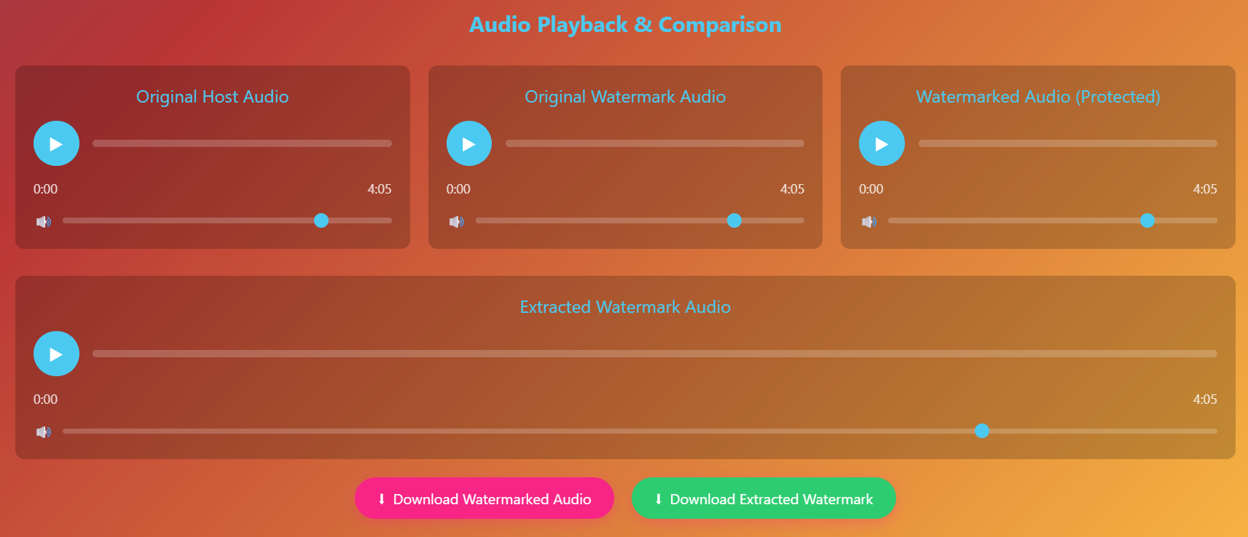
Fig. 4. Audio playback and comparison interface showing host audio, watermarked audio, and extracted watermark signals
Table 2 shows the latency values under various buffer sizes.
Table 2. Latency Measurement Results
Method | Buffer Size (Samples | Watermarking | Latency (ms) | Standard Deviation (ms)
1(Software) | 512 | No | 30.08 | 0.00
1(Software) | 512 | Yes | 30.61 | 0.00
1(Software) | 256 | Yes | 22.63 | 0

The paper investigates a watermarking system for real-time audio, saying it has a low watermarking delay of 0.53 ms, which enables the system for real-time operation. Although latencies of hardware units were augmented by additional processing stages, the watermark embedding was kept to a minimum. The system have reached a 0% bit error rate (BER) under mp3 compression at 128 kbps, its robustness is due to the convolutional coding and spread spectrum techniques. It provides better hiding ability than other methods, although embedding rate in the range of 78.75 bps to 110.25 bps is only possible in the proposed scheme, which is lower than some of the algorithms in the literature, it is far above the minimum require of 20 bps so a certain amount of critical information can be embedded in audio streams. Future work will consider other types of signal processing attacks to provide further experimental confirmation of the robustness of the scheme in a variety of audio environments. The discrepancies between software and hardware latency reporting on this setup can be attributed to the fact that the hardware measurement represents the full end-to-end signal path within the audio domain, while the software method is only timing how long the algorithm takes to process. In software latency is mainly the time to computation of watermark embedding over the processing buffer, which is 0.53 ms. However, the hardware measurement entails additional delays from the OS audio stack, device drivers, buffering, and digital-to-analog/analog-to-digital converters. The evaluation of robustness in this paper is so far concentrated on MP3 compression at 128 kbps, since it is most representative of the recent signal processing followed in nearly all streaming platforms. However, digital watermarking schemes are generally tested against a wider variety of signal processing attacks i.e. resampling, low-pass filtering, amplitude scaling, time-scaling and de-synchronization distortions. since the main focus of this work is on the design and implementation of a low-latency real-time watermark embedding framework) the experimental evaluation was conducted only for compression robustness to preserve controlled testing environment. However, complexity-ordered DSP watermarking schemes are considered more robust than spread spectrum approaches to amplitude scaling and low-pass filtering since they do not alter the host signal until the very last step. In the future, the performance evaluation of robustness will be extended to more signal processing attacks including resampling, filtering, time-scale modification and desynchronization attacks, so as to achieve a better validation for the proposed system.
10. Conclusion
A novel low-latency audio watermarking technique specially designed for real-time applications has been described in this article. It is the first time, to the best of the authors’ knowledge, that a framework with sub-3 ms additional latency in the embedding procedure for interactive applications, e.g. video conferencing, live streaming has been presented. This enables the minimal potential delay to be introduced in the embedding process and thus the scheme is suitable for interactive audio applications. Systematically, the novel time-domain spread spectrum method is refined to meet the critical engineering requirements of optimized buffer management and perceptual shaping, and withstand a complex of severe performance criteria.The system gives a good tradeoff among the important performance requirements by adopting the time-domain spread spectrum technique and combining them with optimized buffer management and perceptual shaping. The experiments confirm that the system runs well on simple consumer-grade hardware without significant distortion concealment, has high perceptual transparency with an average ODG of −0.56, complete robustness against MP3 compression with 0% BER, and a recommended data rate of 110.25 bps. The system is visually good, not very sky blue as usual, 76 t/y is pretty solid for such heat, except the top-right heat is a bit surrounding bad, using prism A+T (because T={2,3,6}) for top-right would be better. The first major limitation of the present study lies in the focus on MP3 compression as the principal robustness test. The impact of simplified psychoacoustic modeling decisions in order to maintain low complexity are also discussed as a main constraint of the work. In addition, the authors believe that further validation with diverse audio types such as noisy field recording and mixed content would help to further generalize the system even though it already demonstrate good performance for all the soft genres of audio tested.
References
1. Falkowski-Gilski, P., Uhl, T.: Current trends in consumption of multimedia content using online streaming platforms: A user-centric survey. Comput. Sci. Rev. 37, 100268 (2020). https://doi.org/https://doi.org/10.1016/j.cosrev.2020.100268.
2. Hill, G.E., Associate, A.P.H.: Defending Distributed Denial Of Service (Ddos) Attacks: Classification And Art. Elem. Educ. Online. 20, 2498–2509 (2021). https://doi.org/10.17051/ilkonline.2021.02.266.
3. Santin-Cruz, C.J., Dolecek, G.J.: Audio Watermarking: Review, Analysis, and Classification of the Most Recent Conventional Cutting-Edge Results. Appl. Sci. 15, (2025). https://doi.org/10.3390/app152111514.
4. Euschi, S., Zermi, N., Med Moad, S., Khaldi, A., Kafi, M.R., Sahu, A.K., Mimoune, N.: Blind audio watermarking for medical data authentication using fractional Charlier transform and adaptive dithered quantization index modulation. Syst. Soft Comput. 8, 200464 (2026). https://doi.org/https://doi.org/10.1016/j.sasc.2026.200464.
5. Power, L., Yeonjin, K., Hee-seob, K., Com, W.W.W.V.: Deep Learning-Driven Speech and Audio High-Speed Processing : Advances in Noise Reduction , Speech Comparator With Low Offset Enhancement , and Real-Time Voice Voltage Analytics Implemented in 45nm CMOS Technology. Natl. J. Speech Audio Process. 1, 9–16 (2025).
6. Gutterman, C., Guo, K., Arora, S., Gilliland, T., Wang, X., Wu, L., Katz-Bassett, E., Zussman, G.: Requet: Real-Time QoE Metric Detection for Encrypted YouTube Traffic. ACM Trans. Multimed. Comput. Commun. Appl. 16, (2020). https://doi.org/10.1145/3394498.
7. Santin-Cruz, C.J., Dolecek, G.J.: Audio Watermarking System in Real-Time Applications. Informatics. 12, (2025). https://doi.org/10.3390/informatics12010001.
8. Nita, V.A., Stanomir, D.: Real-time temporal audio watermarking for mobile communication. In: 2020 13th International Conference on Communications (COMM). pp. 81–84 (2020). https://doi.org/10.1109/COMM48946.2020.9141976.
9. N, P.H., Jamadar, J., Changala, R., Mukherjee, S.K., Dhyani, B., Sachuthananthan, B.: Enhancing the Clarity of Surveillance Footage with Deep Residual Neural Networks. In: 2024 Second International Conference Computational and Characterization Techniques in Engineering & Sciences (IC3TES). pp. 1–5 (2024). https://doi.org/10.1109/IC3TES62412.2024.10877592.
10. Zhao, J., Zong, T., Xiang, Y., Gao, L., Hua, G., Sood, K., Zhang, Y.: SSVS-SSVD Based Desynchronization Attacks Resilient Watermarking Method for Stereo Signals. IEEE/ACM Trans. Audio Speech Lang. Process. 31, 448–461 (2023). https://doi.org/10.1109/TASLP.2022.3225668.
11. Yamni, M., Daoui, A., Karmouni, H., Sayyouri, M., Qjidaa, H., Motahhir, S., Jamil, O., El-Shafai, W., Algarni, A.D., Soliman, N.F., Aly, M.H.: An efficient watermarking algorithm for digital audio data in security applications. Sci. Rep. 13, 18432 (2023). https://doi.org/10.1038/s41598-023-45619-w.
12. Pourhashemi, S.M., Mosleh, M., Erfani, Y.: A novel audio watermarking scheme using ensemble-based watermark detector and discrete wavelet transform. Neural Comput. Appl. 33, 6161–6181 (2021). https://doi.org/10.1007/s00521-020-05389-2.
13. Wu, Q., Ding, R., Wei, J.: Audio Watermarking Algorithm with a Synchronization Mechanism Based on Spectrum Distribution. Secur. Commun. Networks. 2022, 2617107 (2022). https://doi.org/https://doi.org/10.1155/2022/2617107.
14. Wang, S., Yuan, W., Unoki, M.: Multi-Subspace Echo Hiding Based on Time-Frequency Similarities of Audio Signals. IEEE/ACM Trans. Audio, Speech and Lang. Proc. 28, 2349–2363 (2020). https://doi.org/10.1109/TASLP.2020.3013785.
15. Erfani, Y., Pichevar, R., Rouat, J.: Audio Watermarking Using Spikegram and a Two-Dictionary Approach. Trans. Info. For. Sec. 12, 840–852 (2017). https://doi.org/10.1109/TIFS.2016.2636094.
16. Suresh, G., Narla, V.L., Gangwar, D.P., Sahu, A.K.: False-Positive-Free SVD Based Audio Watermarking with Integer Wavelet Transform. Circuits, Syst. Signal Process. 41, 5108–5133 (2022). https://doi.org/10.1007/s00034-022-02023-5.
17. Hu, H.-T., Chang, J.-R., Lin, S.-J.: Synchronous blind audio watermarking via shape configuration of sorted LWT coefficient magnitudes. Signal Processing. 147, 190–202 (2018). https://doi.org/https://doi.org/10.1016/j.sigpro.2018.02.001.
18. Araghi, T.K., Megías, D.: Analysis and effectiveness of deeper levels of SVD on performance of hybrid DWT and SVD watermarking. Multimed. Tools Appl. 83, 3895–3916 (2024). https://doi.org/10.1007/s11042-023-15554-z.

